Hardware Solution

The proposed hardware solution is divided according to the module. The Reservation Free Parking module’s hardware solution consists of an Ultrasonic sensor to detect if there is a car, Arduino board to collect information from the sensors and NodeMCU board to allow the Arduino to send and receive data to the Firebase. The Reservation Free Parking module needs a sensor implemented on each parking spot and so in total a huge number of sensors are needed depending on the number of parking spots. The Ultrasonic sensor has a high accuracy and a low cost. Hence, it was chosen among the other sensors in Table 4-2. Also, the Arduino was chosen over the Raspberry Pi because it is suitable for interfacing sensors with it and has a low cost which makes it more scalable. The connectivity circuit diagram for the module is shown in Figure 4.x.

In addition, the hardware solution for the Reserved Parking module consists of an RFID reader to read the RFID tag on the car, Arduino board to collect information from the RFID reader, LEDs (green and red) to indicate the status of parking area gates and NodeMCU to allow the Arduino to send and receive data to the Firebase. The RFID was chosen because it provides an important functionality over the other sensors in Table 4-2. Unlike the other methods, RFID is able to identify exactly the users entering or leaving the parking area. Hence, the RFID sensor can be implemented at the gates of the parking area and the system only allows those who have registered and reserved a parking spot to enter. The Arduino was also chosen in this module because it is more suitable for the RFID and the LEDs that are interfaced with. To power the system in our testing prototype, a 9V battery will be used. However, a power grid should be used in real life implementation. The connectivity circuit diagram for the module is shown in Figure 4.x.

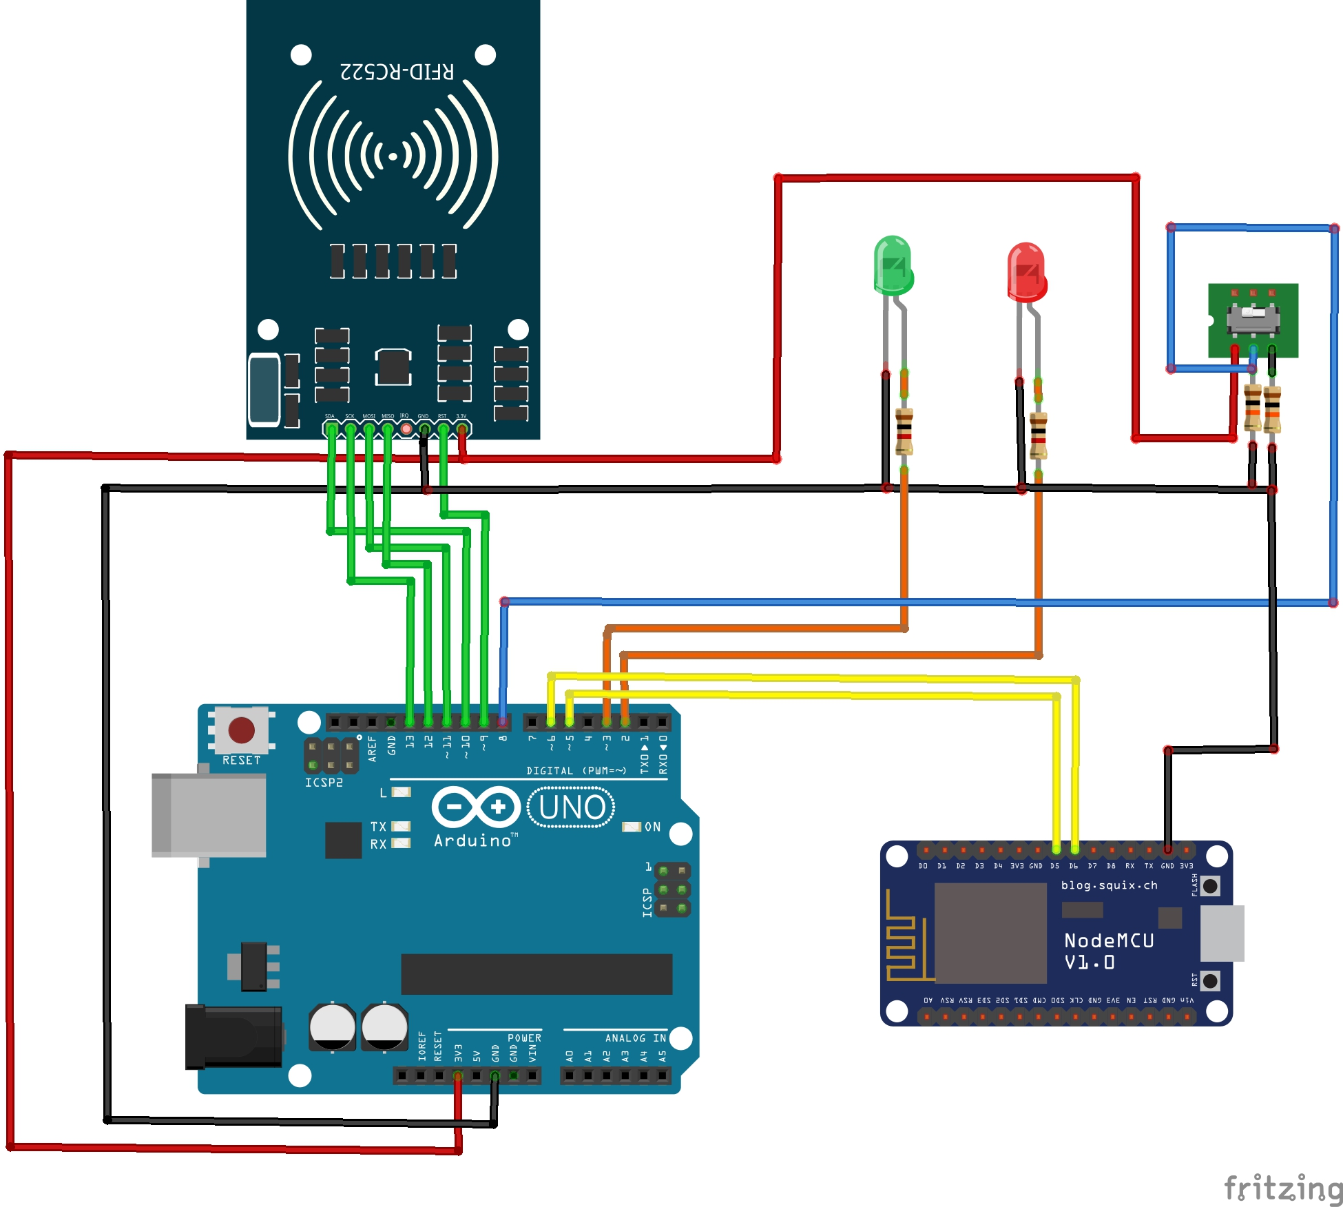

Hardware components

The components of the system besides the microcontrollers Arduino and NodeMCU are: Ultrasonic sensor, RFID sensor and the DPDT switch.

*Ultrasonic Sensor HC-SR04*

HC-SR04 is a distance measurement sensor which is able to detect object and their distance. The sensor is able to give 2cm to 400cm non-contact measurement with an accuracy ranging up to 3mm or less. The sensor includes an ultrasonic transmitter, a receiver, and a control circuit. The four pins to connect the sensor with the Arduino are:

* 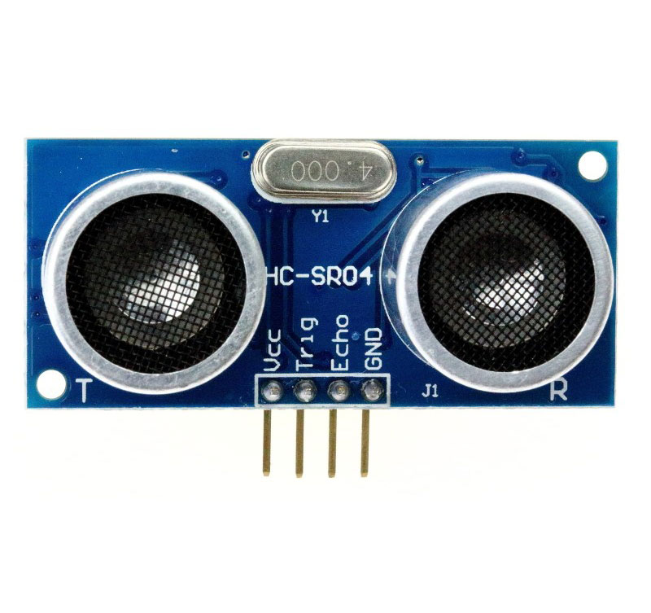VCC: 5v power
* Trig: Trigger (Transmitter) pulse
* Echo: Echo (Receiver) pulse
* GND: 0v ground

The working principle of the sensor is as follows:

* Transmitter (Trig pin) sends a signal (a high frequency sound).
* Signal is reflected when it detects an object.
* Receiver (Echo pin) receives the reflected signal.
* Time is measured by how long it took the signal from to reach the object and then go back to receiver.
* Object distance is calculated from measured time.

*RFID Reader MFRC522*

Radio-Frequency Identification (RFID) uses electromagnetic fields to transfer data over short distances. The RFID system consists of two components:

* 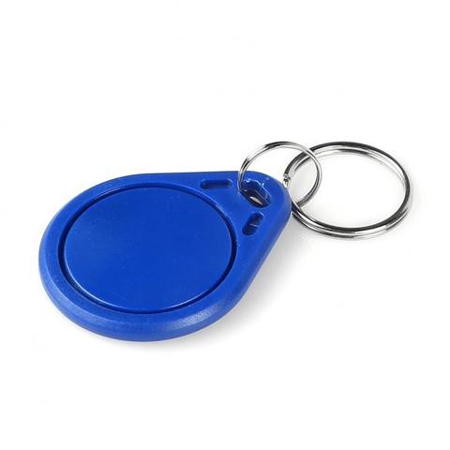RFID tags: The tags hold data known as unique identification (UID). The tag used in our project is the keychain tag (Figure 4.x) and should be attached to the object to be identified.
* RFID reader: A two-way radio transmitter-receiver. The reader (Figure 4.x) sends a signal to the tag to power it up and reads its response which is its UID. The reader is powered with 3.3v, its read distance is 0-60mm. MFRC522 supports SPI, I2C and UART serial communication links. The reader communicates with Arduino using SPI interface.

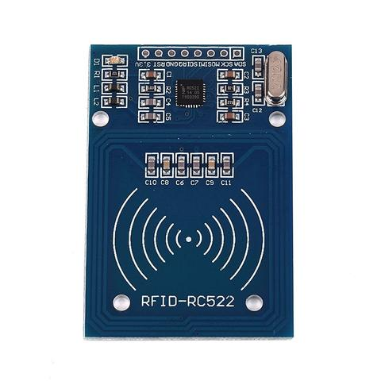There are 8 pins on the RFID reader (Figure 4.x) to connect with Arduino. Four of them connect SPI interface of reader (SDA, SCK, MOSI, MISO) and the other four are for power connections (IRQ – interrupt, RST – reset, GND – ground, 3.3v – power)

*DPDT Switch*

Double Pole Double Throw (DPDT) Switch is a two switch units in one. Figure 4.x shows the schematic diagram of the switch.

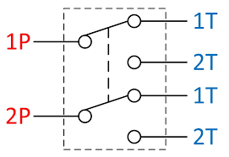

Each switch has three pins, the center pin which is the Common pin (or Pole), the other two pins are the Throw pins. Hence, the name Double Pole (two Poles as in two switch units) and Double Throw (two Throw pins per switch unit). Each Throw pin is a state that the Pole pin can switch to.

Our system only uses one switch unit to switch between zones. High (T1 supplied with 5V) being one zone, Low (T2 supplied with 0V) being the other zone and the switch (P1) switches between them.